**Jenkins task-1**

**1) Install Jenkins and run Jenkins on port number 8081.**

**Create EC2 instance and connect to ssh.**

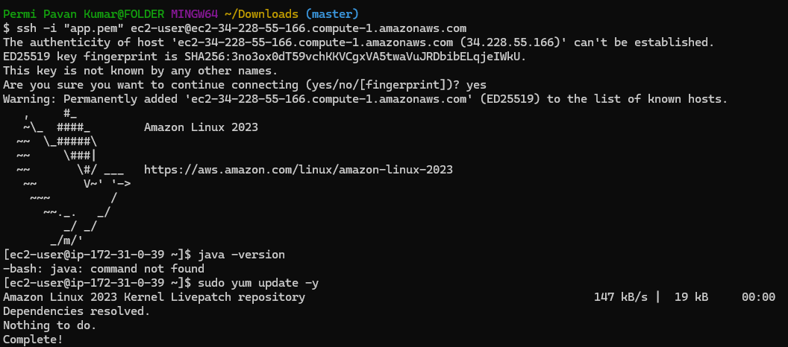

**Update packages**

sudo yum update -y

**Install Java**

sudo yum install java-11-amazon-corretto -y

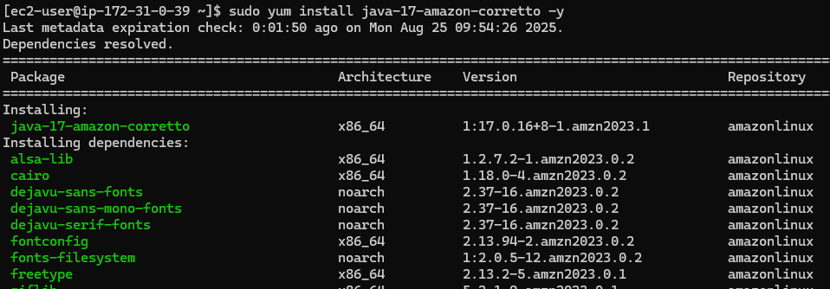

**To check java version**

java -version

**Add Jenkins repository & install Jenkins**

sudo wget -O /etc/yum.repos.d/jenkins.repo \https://pkg.jenkins.io/redhat-stable/jenkins.repo

sudo rpm --import https://pkg.jenkins.io/redhat-stable/jenkins.io-2023.key

sudo yum install jenkins -y

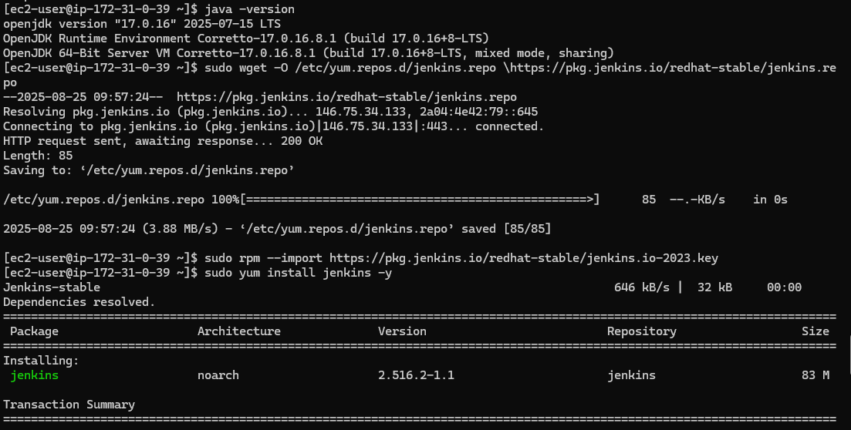

**Start and enable Jenkins**

sudo systemctl daemon-reload

sudo systemctl start jenkins

sudo systemctl enable jenkins

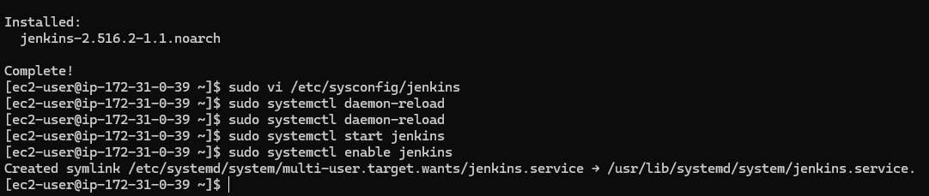

To check the browser with port:8080

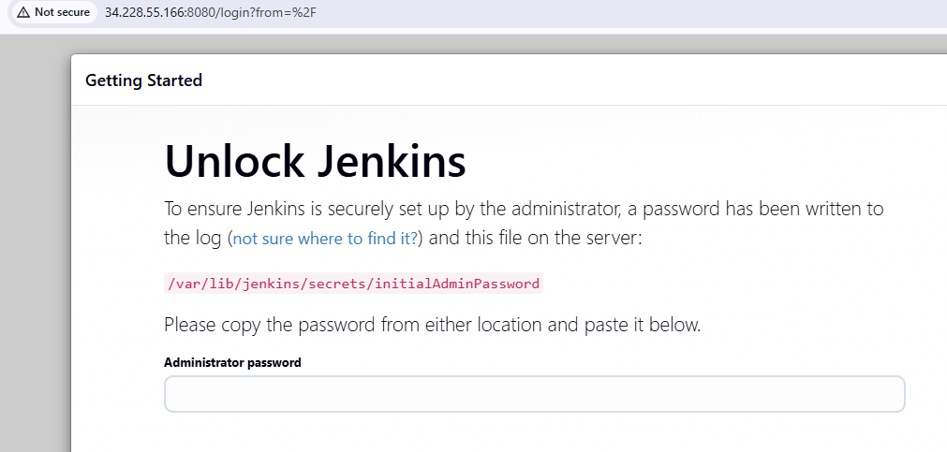

**To run Jenkins in port 8081**

1. Now go to → sudo vi /usr/lib/systemd/system/jenkins.service
2. Update → Environment="JENKINS_PORT=8081"
3. sudo systemctl daemon-reexec
4. sudo systemctl daemon-reload
5. sudo systemctl restart jenkins

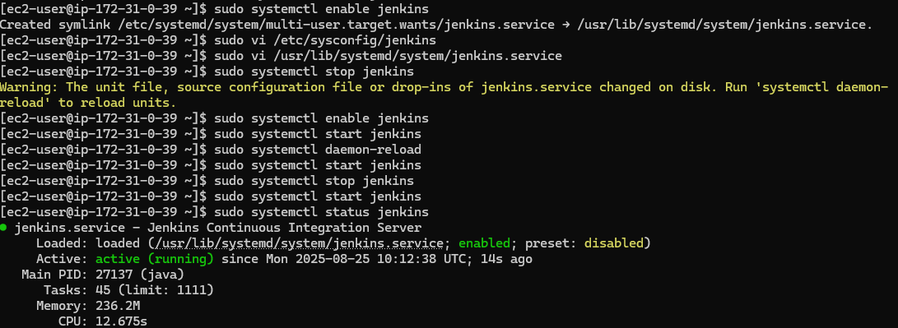

To check Jenkins run in port 8081 in browser.

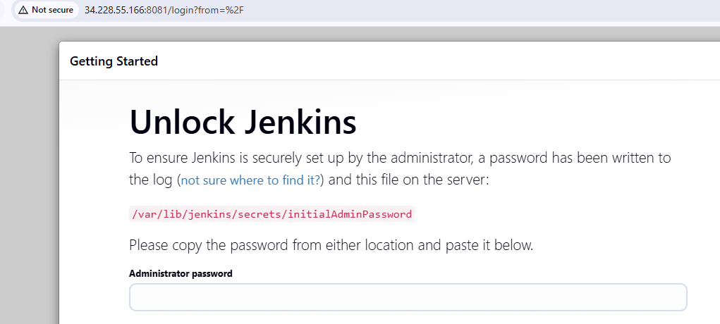

**2) Secure Jenkins server**

sudo cat /var/lib/jenkins/secrets/initialAdminPassword



Copy the above password and past it in the Administrator password



To select install suggested plugins

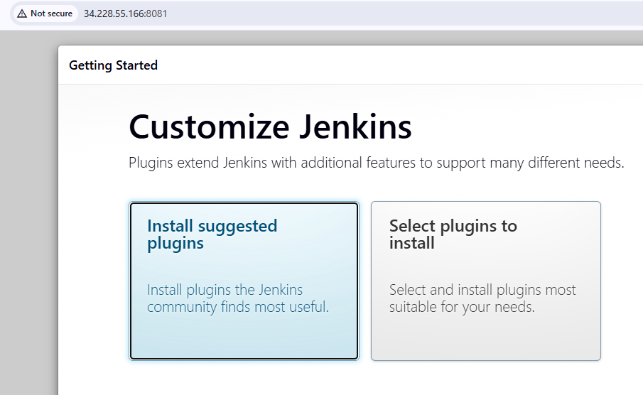

Add username(admin), password and login

After login

Jenkins --> admin --> Security

To change the password and save

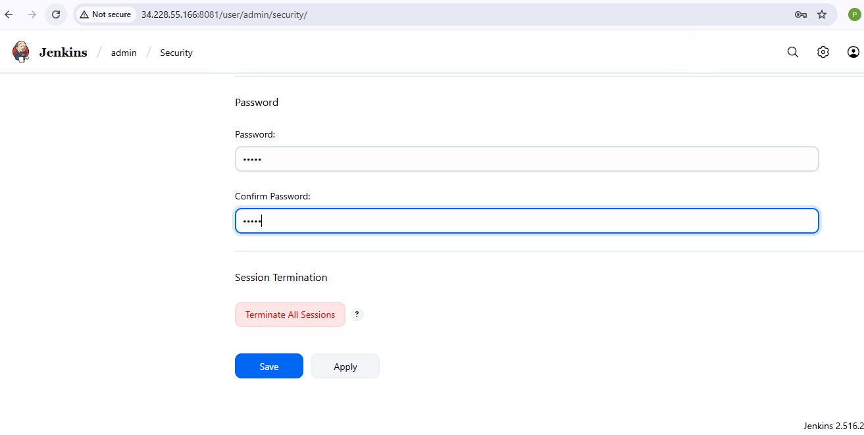

After login with username and password

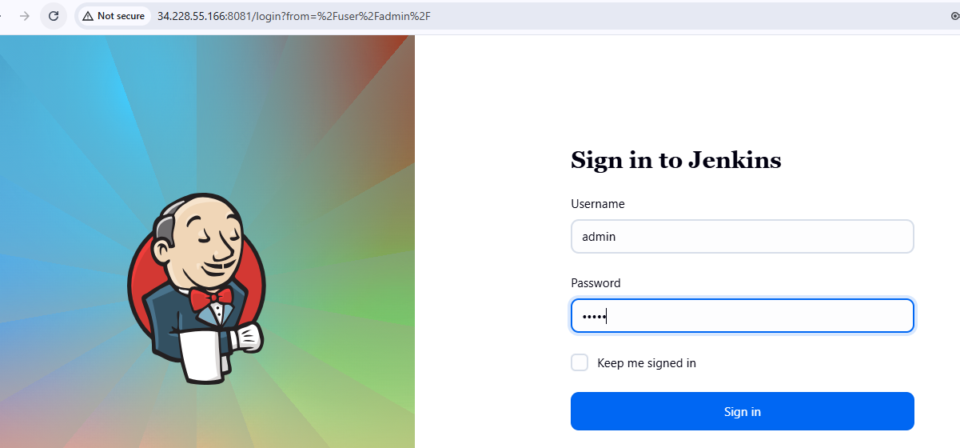

To remove initialAdminPassword

**3) Create users called DevOps, Testing in Jenkins with Limited access.**

Go to Manage Jenkins --> select **users** in **security -->** click **Create User**

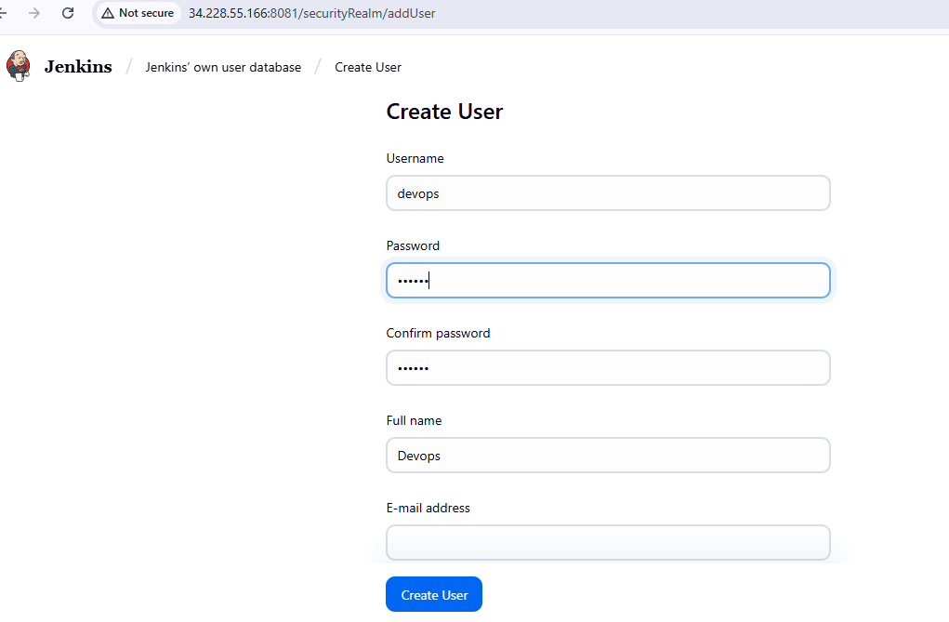

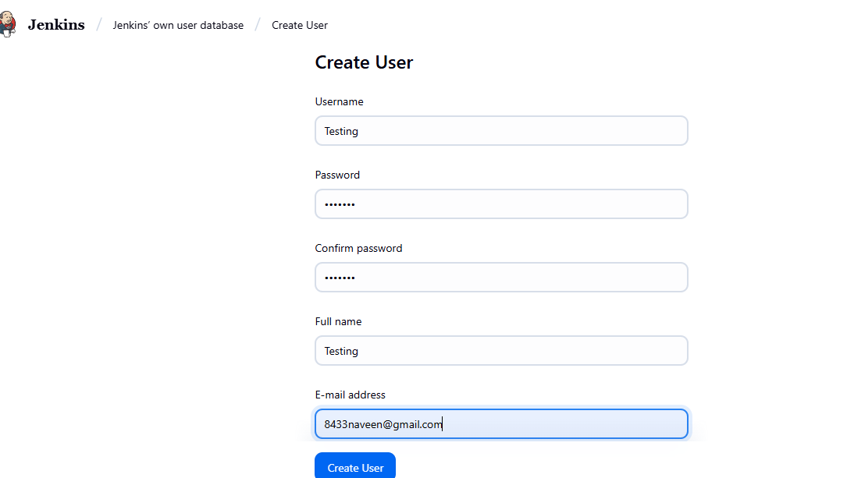

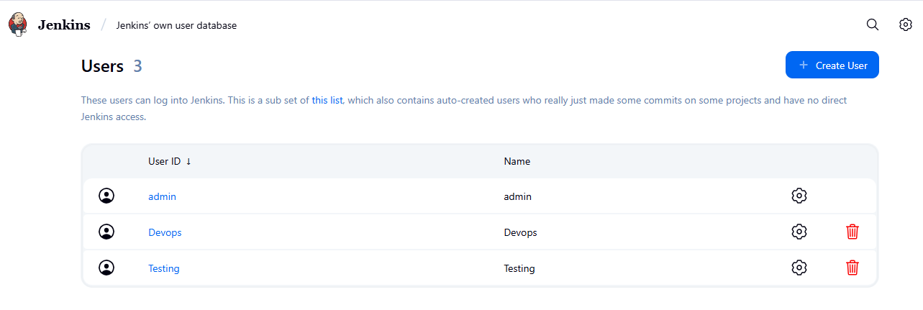

**To give limited access**

Manage Jenkins --> Security --> Authorization -->Project based Matrix Authorization strategy

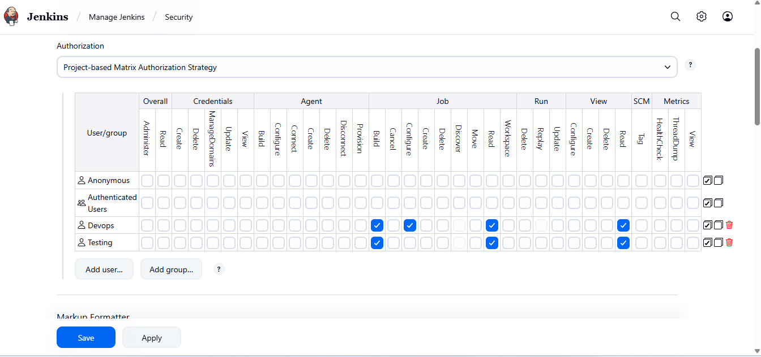

Login to Devops

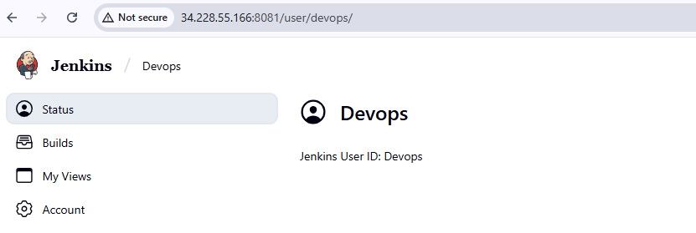

Login to testing

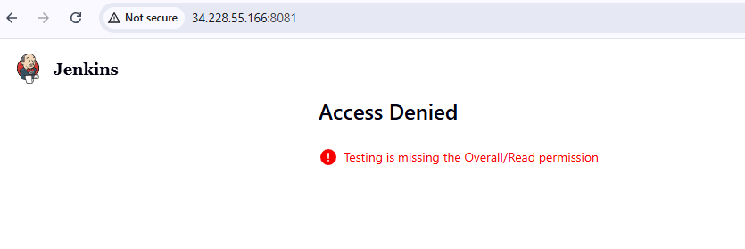

**4) Configure labels and restrict the jobs to execute based on label only.**

**To install Git**

Sudo yum install git

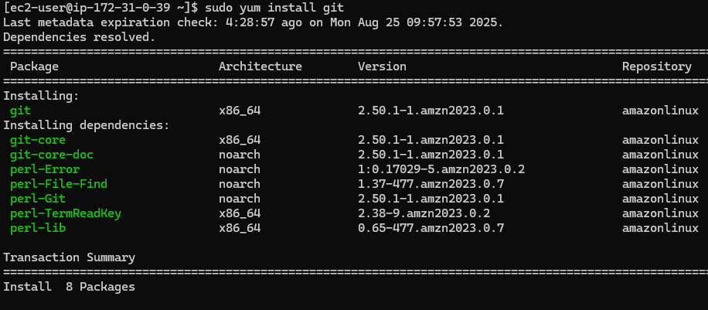

**Manage jenkins → system →** create label **Master**

Create **first-job** having label **Master**

Create **second-job** without label Master

Create **third-job** with wrong label hotfix

**In each job → configure → build steps → execute shell → give seconds**

**I got an issue with disk space**

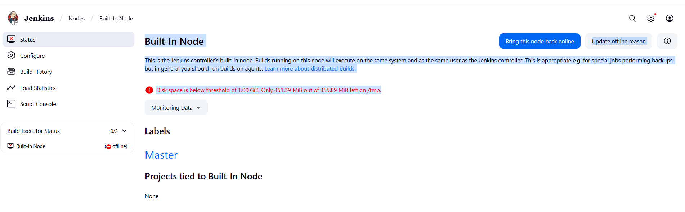

**Change Jenkins temporary directory (recommended)**

Point Jenkins to use **/var/lib/jenkins/tmp**(on your main disk, which has ~18 GB free):

**Create a new tmp directory:  
sudo mkdir -p /var/lib/jenkins/tmp**

**sudo chown -R jenkins:jenkins /var/lib/jenkins/tmp**

**sudo systemctl edit jenkins**

Paste this

**[Service]**

**Environment="JAVA_OPTS=Djava.io.tmpdir=/var/lib/jenkins/tmp"**

**Then reload**

**sudo systemctl daemon-reload**

**sudo systemctl restart jenkins**

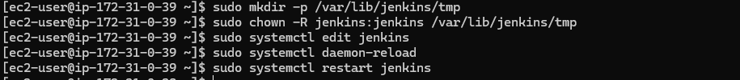

**Then check the created items**

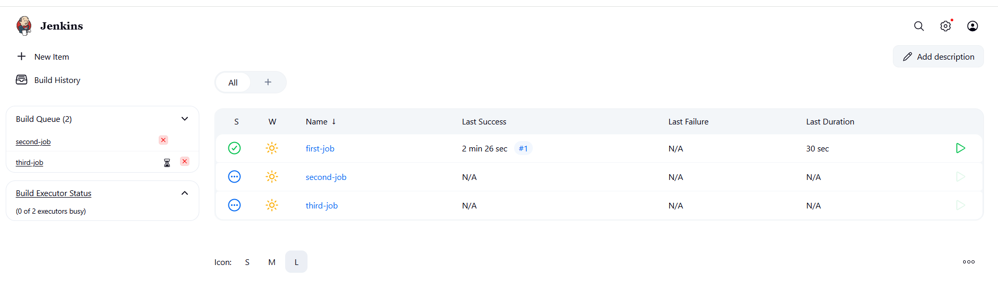

Here **first-job item** only executed because its having label **Master** other jobs notconnected to label Master

**5) Create Three sample jobs using the below URL.**  
   [https://github.com/betawins/Techie_horizon_Login_app.git](https://github.com/betawins/Techie_horizon_Login_app.git" \t "https://app.slack.com/client/T03TRQ064Q0/_blank)

**Created three different jobs with different time stamps with label master is already in jenkins configured label as master.**

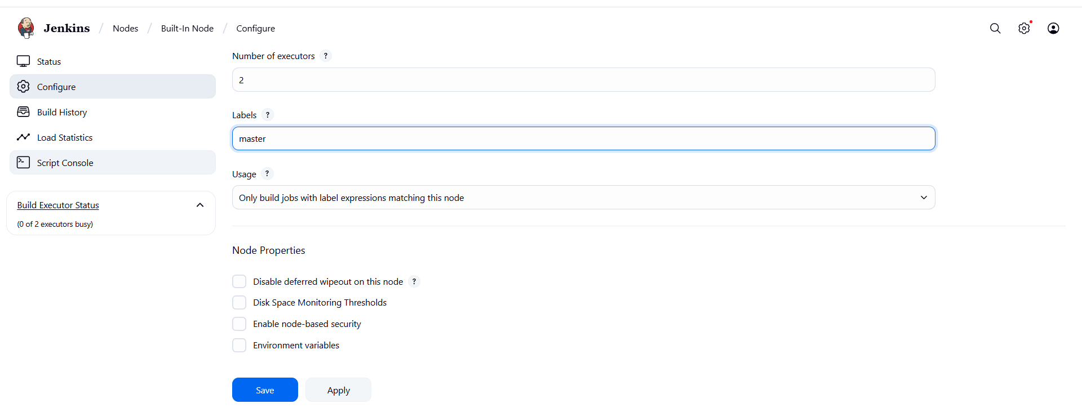

**For configuration add git url**

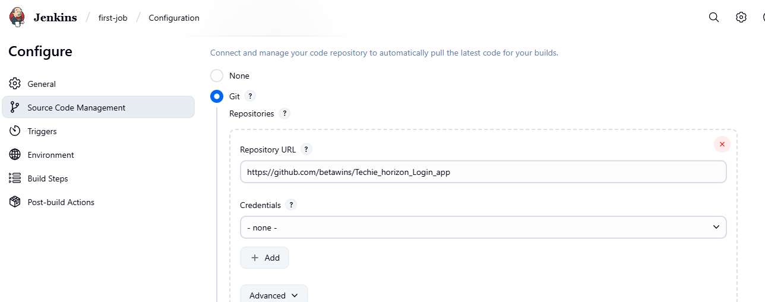

After completion the builtclick **Built Now**

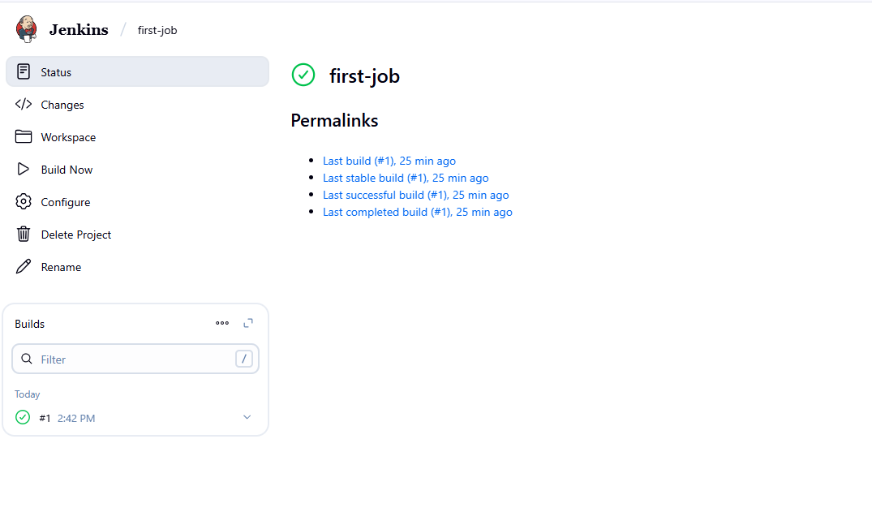

**Then check all three items are executed with label masters**

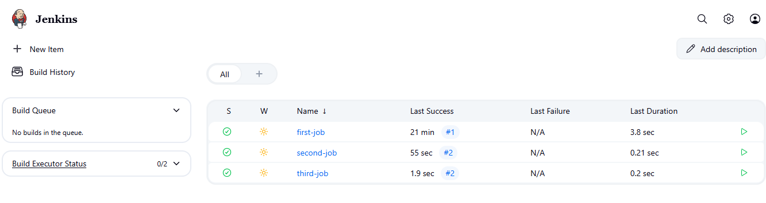

**6) Create one Jenkins job using git hub Private repository.**

**Go to github and create private-repo**

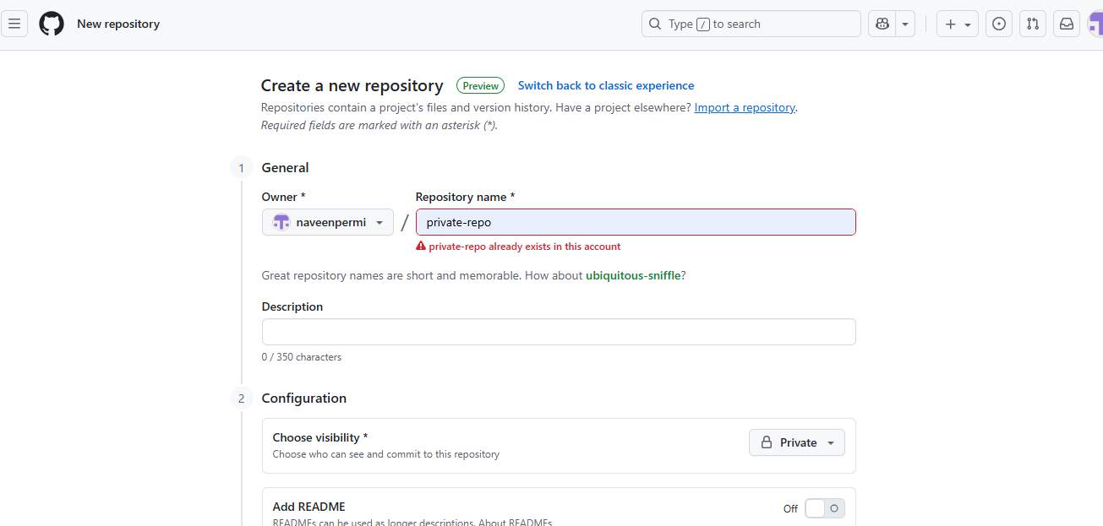

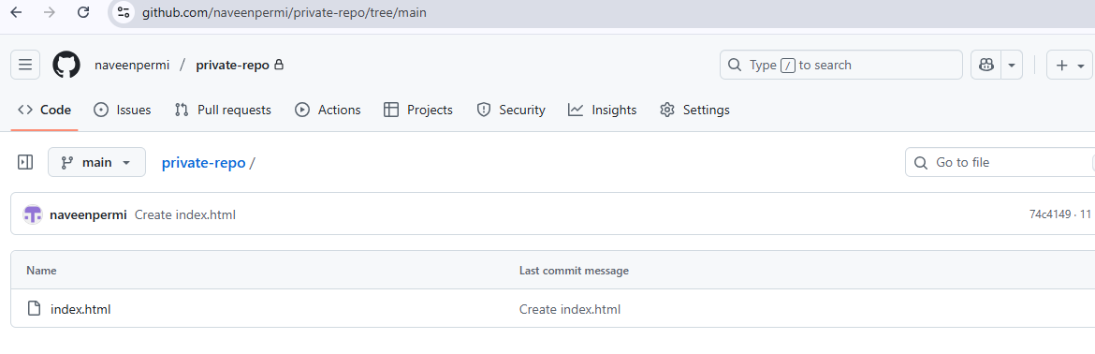

**Go to github and create access token with repo**

Go to **github → settings → developer settings → personal access tokens → Tokens (classic) → Generate new token →** click **Generate new token (classic)**

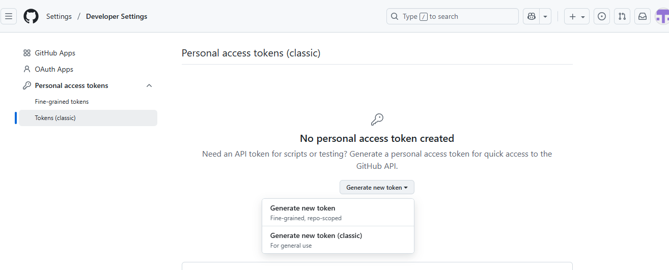

Enter Node **→** select **repo →** click **Generate token**

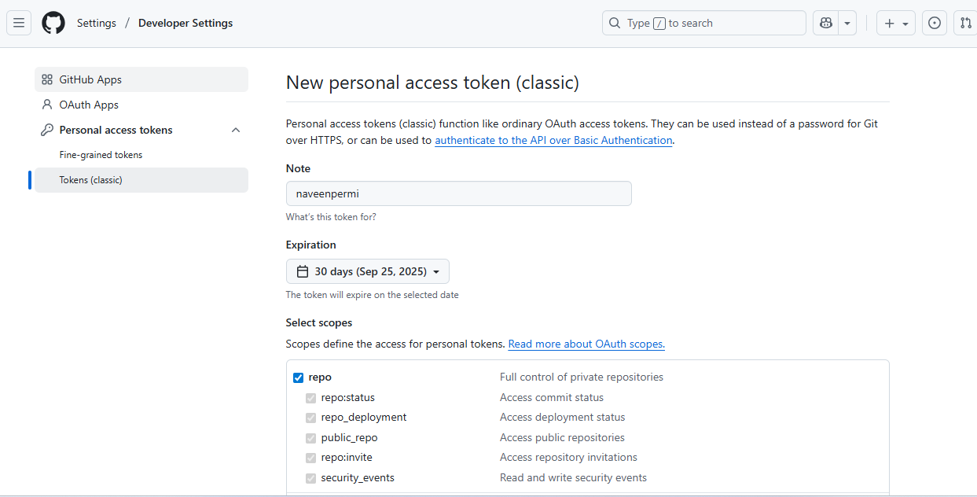

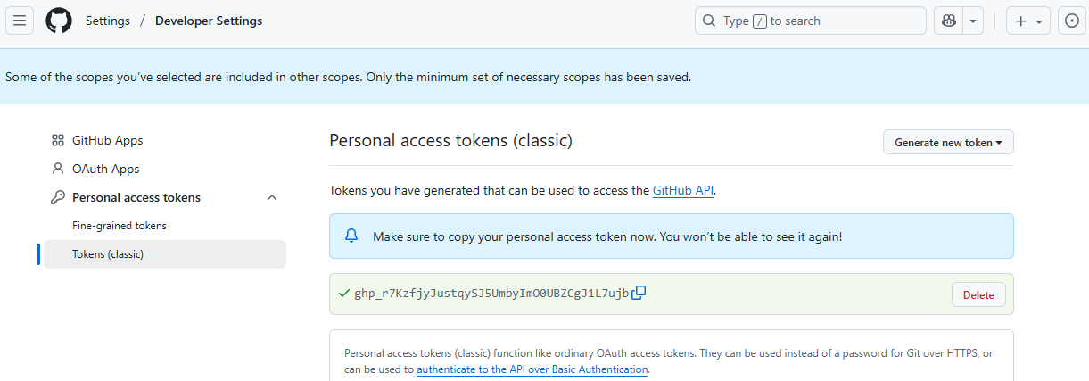

Go to **Jenkins ---> Manage Jenkins ---> Credentials ---> System ---> Global credentials(unrestricted)**

In jenkins create **credentials with github username and generated path**

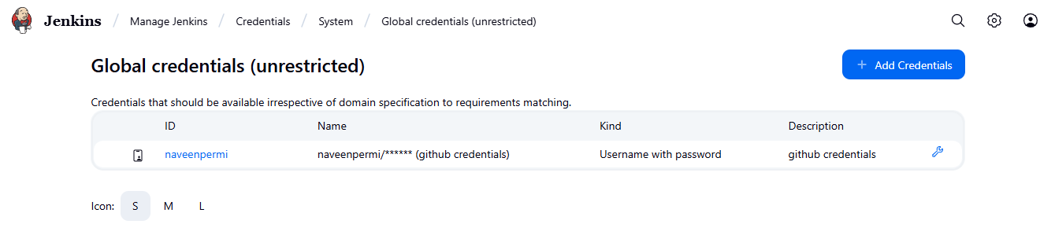

Create **private-job** with **private url** with **credentials** and **run build.**

